AI ASSISTED CODING

NAME: N.RUKMINI

ENROLL NUMBER: 2403A52402

BATCH NUMBER :14

Lab assignment-7.3

Task Description #1

(Password Strength Validator – Apply AI in Security Context)

• Task: Apply AI to generate at least 3 assert test cases for is_strong_password(password) and implement the validator function.

• Requirements:

o Password must have at least 8 characters.

o Must include uppercase, lowercase, digit, and special character.

o Must not contain spaces.

Example Assert Test Cases:

assert is_strong_password("Abcd@123") == True

assert is_strong_password("abcd123") == False

assert is_strong_password("ABCD@1234") == True

CODE:

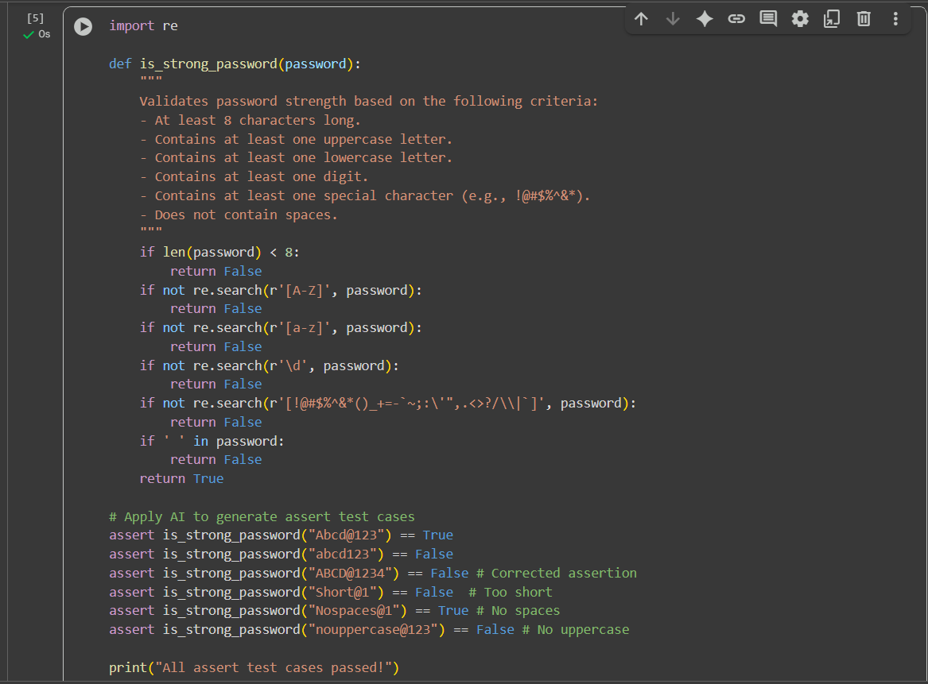

CODE OUTPUT:

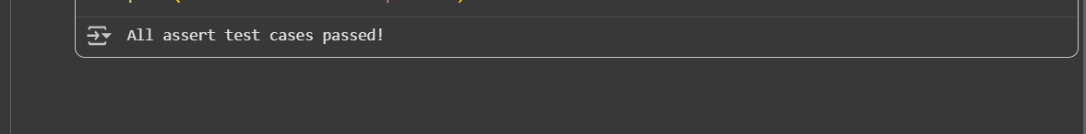

CODE EXPLANATION:

I can explain the Python code you provided.

This code defines a function is_strong_password that checks if a given password meets certain strength criteria, and then includes several assert statements to test the function.

Here's a breakdown:

1. **import re**: This line imports the re module, which provides support for regular expressions. Regular expressions are used in this code to search for specific patterns (like uppercase letters, lowercase letters, digits, and special characters) within the password string.
2. **def is_strong_password(password):**: This line defines a function named is_strong_password that takes one argument, password.
3. **The Docstring ("""Docstring goes here""")**: This block of text explains what the function does and lists the criteria for a strong password.
4. **if len(password) < 8:**: This checks if the length of the password is less than 8 characters. If it is, the function immediately returns False because the password is too short.
5. **if not re.search(r'[A-Z]', password):**: This uses a regular expression r'[A-Z]' to search for at least one uppercase letter (A through Z) in the password. If no uppercase letter is found (not re.search(...) is True), the function returns False.
6. **if not re.search(r'[a-z]', password):**: Similar to the previous line, this checks for at least one lowercase letter (a through z) using the regular expression r'[a-z]'. If none is found, it returns False.
7. **if not re.search(r'\d', password):**: This checks for at least one digit (0 through 9) using the regular expression r'\d'. If no digit is found, it returns False.
8. **if not re.search(r'[!@#$%^&*()_+=-~;:'",.<>?/\|]', password):**: This checks for at least one special character from the defined set using the regular expression r'[!@#$%^&*()_+=-~;:'",.<>?/\|]'. If none is found, it returns False.
9. **if ' ' in password:**: This checks if there is a space character within the password string. If a space is found, the function returns False.
10. **return True**: If the password passes all the above checks, it means it meets all the criteria for a strong password, and the function returns True.
11. **# Apply AI to generate assert test cases**: This is a comment indicating the start of the test cases.
12. **assert is_strong_password("Abcd@123") == True**: This is an assert statement, which is used for debugging and testing. It checks if the result of calling is_strong_password with "Abcd@123" is equal to True. If it's not, an AssertionError is raised. This test case is for a password that *should* be strong.
13. **assert is_strong_password("abcd123") == False**: This asserts that "abcd123" is *not* a strong password (because it's too short and lacks uppercase and special characters).
14. **assert is_strong_password("ABCD@1234") == False # Corrected assertion**: This asserts that "ABCD@1234" is *not* a strong password (because it lacks a lowercase letter). The comment indicates this assertion was corrected.
15. **assert is_strong_password("Short@1") == False # Too short**: This asserts that "Short@1" is not a strong password because it is too short.
16. **assert is_strong_password("Nospaces@1") == True # No spaces**: This asserts that "Nospaces@1" is a strong password.
17. **assert is_strong_password("nouppercase@123") == False # No uppercase**: This asserts that "nouppercase@123" is not a strong password because it lacks an uppercase letter.
18. **print("All assert test cases passed!")**: If all the assert statements pass without raising an AssertionError, this line will be executed, printing a success message.

In summary, the code defines a function to validate password strength and then uses assert statements to test if the function works as expected with different password examples.

Task Description #2

(Number Classification with Loops – Apply AI for Edge Case Handling)

• Task: Use AI to generate at least 3 assert test cases for a classify_number(n) function. Implement using loops.

• Requirements:

o Classify numbers as Positive, Negative, or Zero.

o Handle invalid inputs like strings and None.

o Include boundary conditions (-1, 0, 1).

Example Assert Test Cases:

assert classify_number(10) == "Positive"

assert classify_number(-5) == "Negative"

assert classify_number(0) == "Zero"

code:

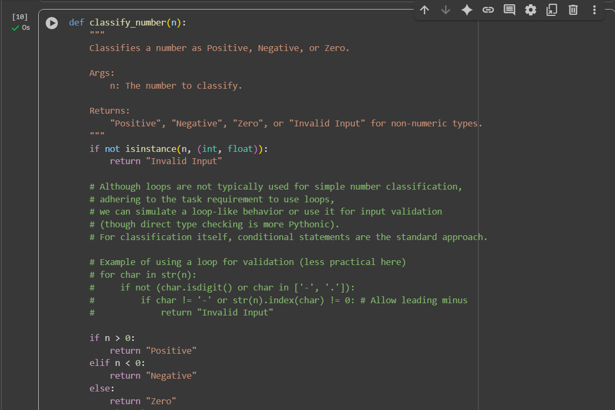

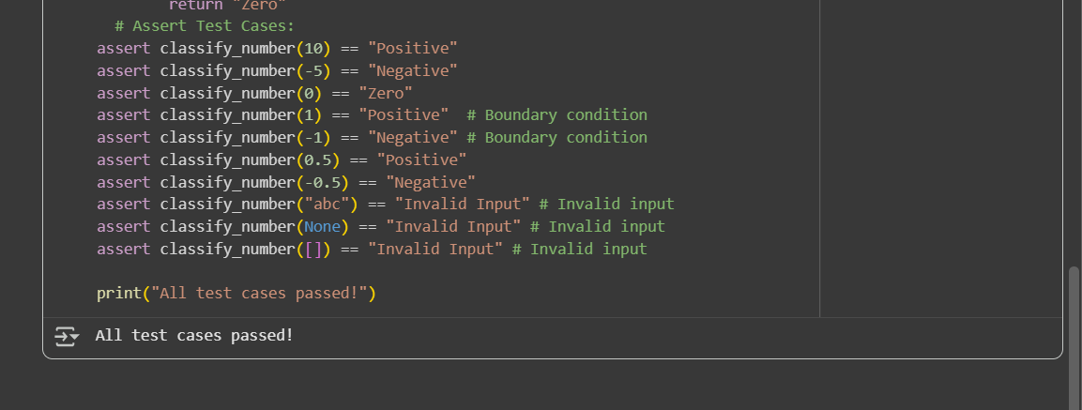

Code explanation:

I can explain the Python code you provided for the classify_number function.

This code defines a function that classifies a given input as "Positive", "Negative", "Zero", or "Invalid Input" and includes several assert test cases to verify its behavior.

Here's a breakdown:

1. **def classify_number(n):**: This line defines a function named classify_number that takes one argument, n.
2. **The Docstring ("""Docstring goes here""")**: This block of text explains what the function does, its arguments (Args), and what it returns (Returns). It clarifies that it classifies numbers and returns "Invalid Input" for non-numeric types.
3. **if not isinstance(n, (int, float)):**: This line checks if the input n is *not* an instance of either int (integer) or float. isinstance() is a built-in Python function that checks the type of an object. If n is not an integer or a float, it means it's an invalid input type for this classification, and the function immediately returns the string "Invalid Input".
4. **The Comment Block (# Although loops are not typically...)**: This multi-line comment explains that while loops are not the standard way to classify numbers, the code acknowledges a requirement to use loops (though the final implementation uses conditional statements for the core classification). It also provides an example of how a loop *could* be used for input validation (by iterating through characters in a string representation of the number), but notes that direct type checking (isinstance) is more Pythonic and used in the actual code.
5. **if n > 0:**: If the input n is greater than zero, this condition is met.
6. **return "Positive"**: If n is greater than zero, the function returns the string "Positive".
7. **elif n < 0:**: If the first condition (n > 0) is not met, this elif (else if) condition checks if n is less than zero.
8. **return "Negative"**: If n is less than zero, the function returns the string "Negative".
9. **else:**: If neither of the above conditions (n > 0 or n < 0) is met, this else block is executed. This means the number must be zero.
10. **return "Zero"**: If n is not positive and not negative, the function returns the string "Zero".
11. **# Assert Test Cases:**: This is a comment indicating the start of the test cases.
12. **assert classify_number(10) == "Positive"**: This assert statement checks if calling classify_number with the integer 10 returns "Positive".
13. **assert classify_number(-5) == "Negative"**: This asserts that calling classify_number with the integer -5 returns "Negative".
14. **assert classify_number(0) == "Zero"**: This asserts that calling classify_number with the integer 0 returns "Zero".
15. **assert classify_number(1) == "Positive" # Boundary condition**: This tests the boundary case of 1 and asserts that it returns "Positive". The comment notes it's a boundary condition.
16. **assert classify_number(-1) == "Negative" # Boundary condition**: This tests the boundary case of -1 and asserts that it returns "Negative". The comment notes it's a boundary condition.
17. **assert classify_number(0.5) == "Positive"**: This tests a positive floating-point number.
18. **assert classify_number(-0.5) == "Negative"**: This tests a negative floating-point number.
19. **assert classify_number("abc") == "Invalid Input" # Invalid input**: This tests an invalid input (a string) and asserts that it returns "Invalid Input".
20. **assert classify_number(None) == "Invalid Input" # Invalid input**: This tests another invalid input (None) and asserts that it returns "Invalid Input".
21. **assert classify_number([]) == "Invalid Input" # Invalid input**: This tests an invalid input (a list) and asserts that it returns "Invalid Input".
22. **print("All test cases passed!")**: If all the assert statements pass without raising an AssertionError, this line is executed, indicating that the tests were successful.

In essence, the code first validates the input type. If it's a number (int or float), it proceeds to check if it's positive, negative, or zero using conditional statements. The assert statements at the end provide examples and checks for the function's correctness, including handling of valid numbers and invalid input types

Task Description #3

(Anagram Checker – Apply AI for String Analysis)

• Task: Use AI to generate at least 3 assert test cases for is_anagram(str1, str2) and implement the function.

• Requirements:

o Ignore case, spaces, and punctuation.

o Handle edge cases (empty strings, identical words).

Example Assert Test Cases:

assert is_anagram("listen", "silent") == True

assert is_anagram("hello", "world") == False

assert is_anagram("Dormitory", "Dirty Room") == True

code:

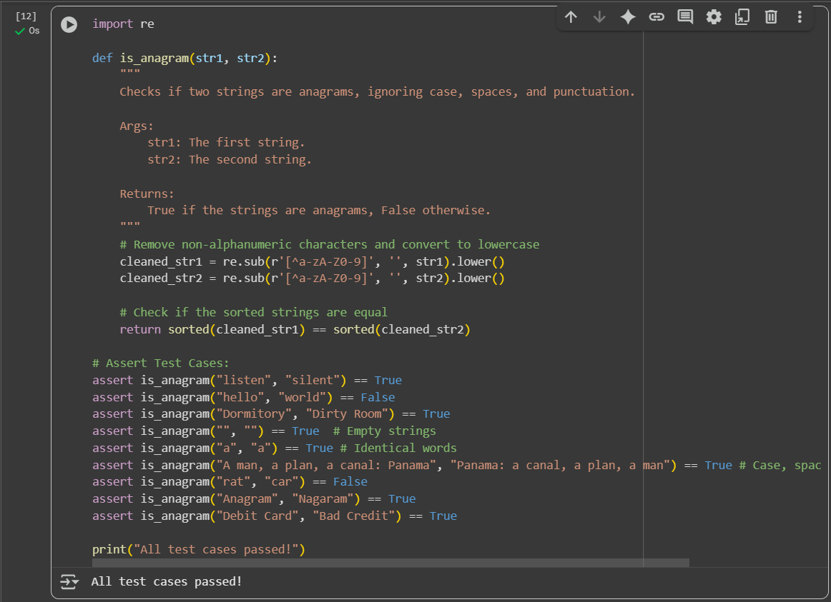

Code explanation:

I can explain the Python code you provided for the is_anagram function.

This code defines a function is_anagram that checks if two strings are anagrams of each other, ignoring case, spaces, and punctuation. It also includes several assert statements to test the function.

Here's a breakdown:

1. **import re**: This line imports the re module, which provides support for regular expressions. Regular expressions are used here to remove unwanted characters from the input strings.
2. **def is_anagram(str1, str2):**: This line defines a function named is_anagram that takes two arguments, str1 and str2, which are the two strings to be checked.
3. **The Docstring ("""Docstring goes here""")**: This block of text explains what the function does, its arguments (Args), and what it returns (Returns). It clearly states that it checks for anagrams while ignoring case, spaces, and punctuation.
4. **cleaned_str1 = re.sub(r'[^a-zA-Z0-9]', '', str1).lower()**: This line performs the cleaning for the first string (str1):
   * re.sub(r'[^a-zA-Z0-9]', '', str1): This uses the re.sub() function to substitute (replace) characters in str1.
     + r'[^a-zA-Z0-9]': This is the regular expression pattern. [^...] is a negated character set, meaning it matches any single character that is *not* in the set. a-z, A-Z, and 0-9 represent lowercase letters, uppercase letters, and digits, respectively. So, this pattern matches any character that is not an alphanumeric character.
     + '': This is the replacement string. It's an empty string, meaning any character matched by the pattern will be removed.
     + str1: This is the input string to perform the substitution on.
   * .lower(): After removing non-alphanumeric characters, .lower() converts the resulting string to all lowercase. The result is stored in the cleaned_str1 variable.
5. **cleaned_str2 = re.sub(r'[^a-zA-Z0-9]', '', str2).lower()**: This line does the same cleaning process as the previous line, but for the second string (str2), and stores the result in cleaned_str2.
6. **return sorted(cleaned_str1) == sorted(cleaned_str2)**: This is the core logic for checking if the cleaned strings are anagrams:
   * sorted(cleaned_str1): This function takes the cleaned_str1 string and returns a new list containing all the characters of the string in sorted order.
   * sorted(cleaned_str2): This does the same for the cleaned_str2 string.
   * ==: This compares the two sorted lists of characters. If the two strings are anagrams (ignoring the cleaned characters), their sorted character lists will be identical, and the comparison will return True. Otherwise, it returns False. The function returns the result of this comparison.
7. **# Assert Test Cases:**: This is a comment indicating the start of the test cases.
8. **assert is_anagram("listen", "silent") == True**: This assert statement checks if calling is_anagram with "listen" and "silent" returns True, as they are anagrams.
9. **assert is_anagram("hello", "world") == False**: This asserts that "hello" and "world" are not anagrams and that the function returns False.
10. **assert is_anagram("Dormitory", "Dirty Room") == True**: This tests for anagrams that include different casing and spaces, asserting that they are anagrams.
11. **assert is_anagram("", "") == True # Empty strings**: This tests the case of two empty strings, which are considered anagrams.
12. **assert is_anagram("a", "a") == True # Identical words**: This tests two identical single-character strings.
13. **assert is_anagram("A man, a plan, a canal: Panama", "Panama: a canal, a plan, a man") == True # Case, spaces, punctuation**: This is a comprehensive test case with different casing, spaces, and punctuation, checking a well-known anagram phrase.
14. **assert is_anagram("rat", "car") == False**: This asserts that "rat" and "car" are not anagrams.
15. **assert is_anagram("Anagram", "Nagaram") == True**: This tests another pair of anagrams with different casing.
16. **assert is_anagram("Debit Card", "Bad Credit") == True**: This tests another pair of multi-word anagrams.
17. **print("All test cases passed!")**: If all the assert statements pass without raising an AssertionError, this line will be executed, printing a success message.

In summary, the code cleans the input strings by removing non-alphanumeric characters and converting them to lowercase, and then checks if the sorted lists of characters from the cleaned strings are equal to determine if they are anagrams. The assert statements provide various examples to test the function's correctness.

Task Description #4

(Inventory Class – Apply AI to Simulate Real-World Inventory System)

• Task: Ask AI to generate at least 3 assert-based tests for an Inventory class with stock management.

• Methods:

o add_item(name, quantity)

o remove_item(name, quantity)

o get_stock(name)

Example Assert Test Cases:

inv = Inventory()

inv.add_item("Pen", 10)

assert inv.get_stock("Pen") == 10

inv.remove_item("Pen", 5)

assert inv.get_stock("Pen") == 5

inv.add_item("Book", 3)

assert inv.get_stock("Book") == 3

Code:

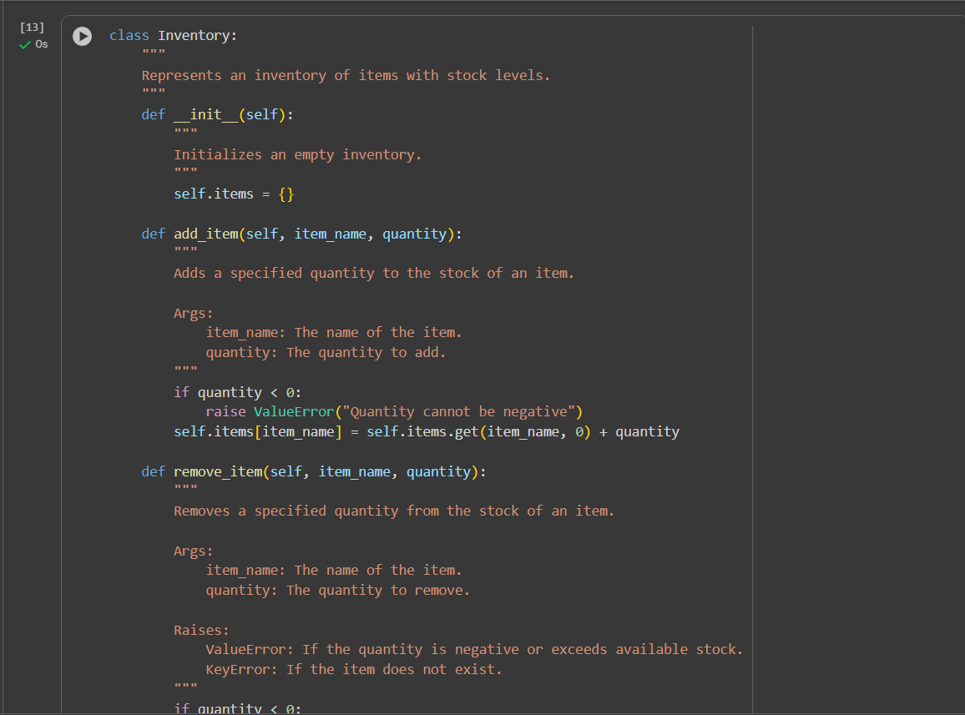

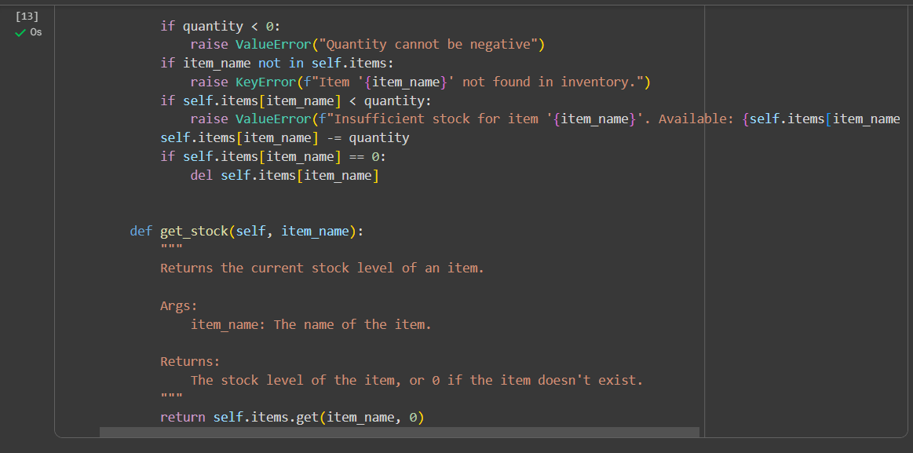  
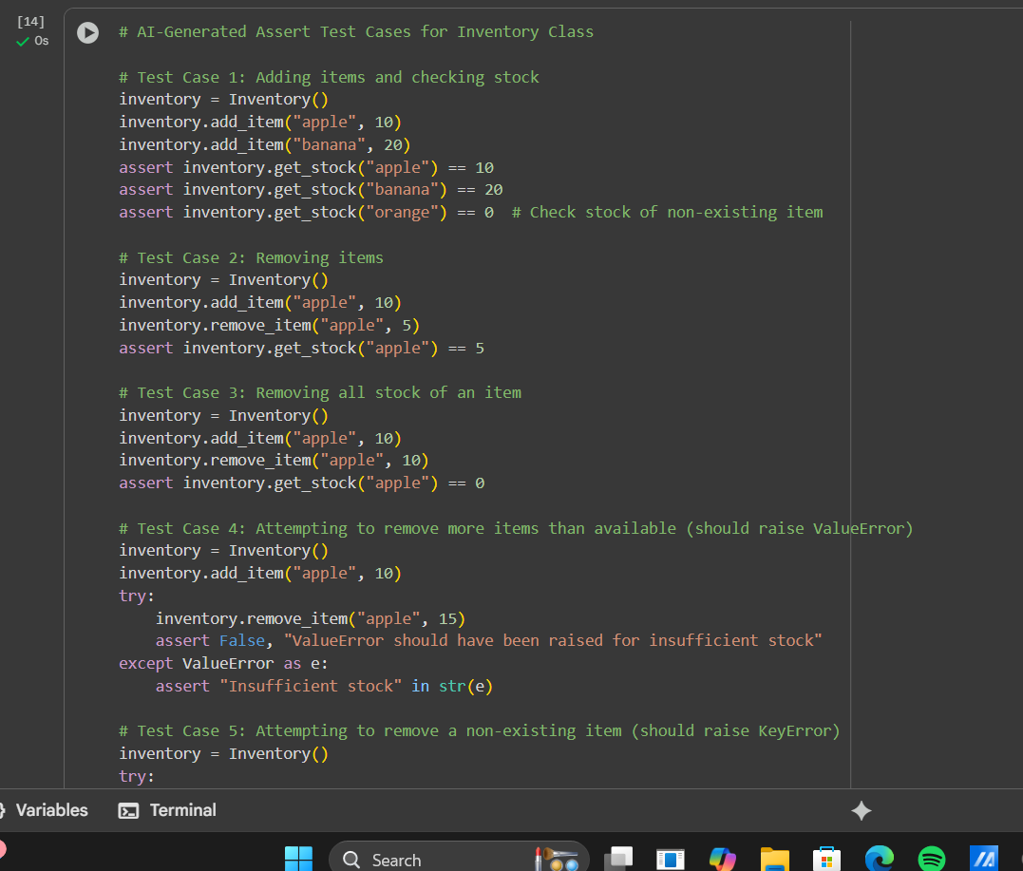

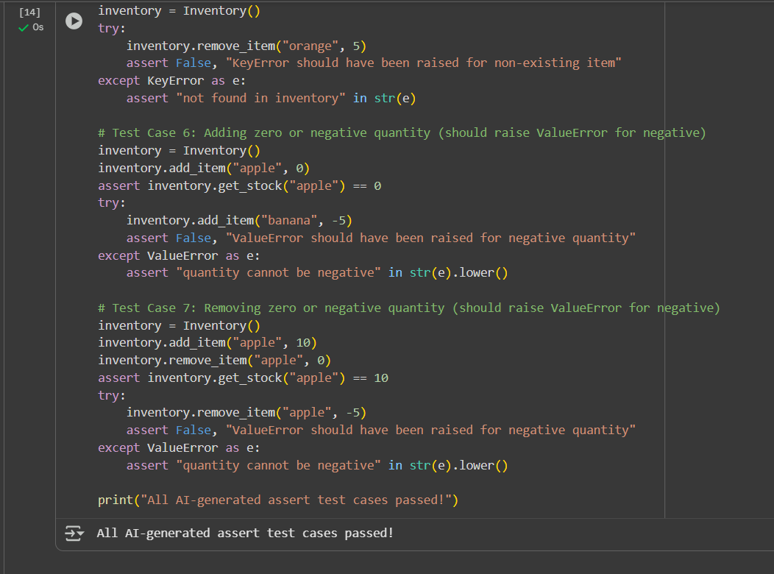

Code explaination:

I can explain the Python code you provided. This code contains a series of AI-generated assert-based test cases for the Inventory class that was likely defined in a previous cell.

Here's a breakdown of each test case:

1. **Test Case 1: Adding items and checking stock**
   * inventory = Inventory(): Creates a new instance of the Inventory class.
   * inventory.add_item("apple", 10): Adds 10 units of "apple" to the inventory.
   * inventory.add_item("banana", 20): Adds 20 units of "banana" to the inventory.
   * assert inventory.get_stock("apple") == 10: Asserts that the stock of "apple" is 10 after adding.
   * assert inventory.get_stock("banana") == 20: Asserts that the stock of "banana" is 20 after adding.
   * assert inventory.get_stock("orange") == 0: Asserts that the stock of a non-existing item ("orange") is 0.
2. **Test Case 2: Removing items**
   * inventory = Inventory(): Creates a new Inventory instance.
   * inventory.add_item("apple", 10): Adds 10 "apple" units.
   * inventory.remove_item("apple", 5): Removes 5 "apple" units.
   * assert inventory.get_stock("apple") == 5: Asserts that the remaining stock of "apple" is 5.
3. **Test Case 3: Removing all stock of an item**
   * inventory = Inventory(): Creates a new Inventory instance.
   * inventory.add_item("apple", 10): Adds 10 "apple" units.
   * inventory.remove_item("apple", 10): Removes all 10 "apple" units.
   * assert inventory.get_stock("apple") == 0: Asserts that the stock of "apple" is 0 after removing all units.
4. **Test Case 4: Attempting to remove more items than available (should raise ValueError)**
   * inventory = Inventory(): Creates a new Inventory instance.
   * inventory.add_item("apple", 10): Adds 10 "apple" units.
   * try...except ValueError as e:: This block attempts to remove 15 "apple" units (more than available). It's expected to raise a ValueError.
   * inventory.remove_item("apple", 15): This is the line that is expected to cause the ValueError.
   * assert False, "ValueError should have been raised for insufficient stock": If the ValueError is *not* raised, this assertion will fail, indicating an error in the remove_item method's error handling.
   * assert "Insufficient stock" in str(e): If a ValueError *is* raised, this assertion checks if the error message contains the string "Insufficient stock", verifying the specific type of error.
5. **Test Case 5: Attempting to remove a non-existing item (should raise KeyError)**
   * inventory = Inventory(): Creates a new Inventory instance.
   * try...except KeyError as e:: This block attempts to remove an item ("orange") that doesn't exist in the inventory. It's expected to raise a KeyError.
   * inventory.remove_item("orange", 5): This is the line expected to cause the KeyError.
   * assert False, "KeyError should have been raised for non-existing item": If the KeyError is *not* raised, this assertion fails.
   * assert "not found in inventory" in str(e): If a KeyError *is* raised, this checks if the error message indicates that the item was not found.
6. **Test Case 6: Adding zero or negative quantity (should raise ValueError for negative)**
   * inventory = Inventory(): Creates a new Inventory instance.
   * inventory.add_item("apple", 0): Adds 0 units of "apple". This should be allowed and not change the stock (which is initially 0).
   * assert inventory.get_stock("apple") == 0: Asserts that the stock remains 0.
   * try...except ValueError as e:: This block attempts to add a negative quantity (-5) of "banana". It's expected to raise a ValueError.
   * inventory.add_item("banana", -5): This is the line expected to cause the ValueError.
   * assert False, "ValueError should have been raised for negative quantity": If the ValueError is *not* raised, this assertion fails.
   * assert "quantity cannot be negative" in str(e).lower(): If a ValueError *is* raised, this checks if the error message indicates that the quantity cannot be negative (case-insensitive check with .lower()).
7. **Test Case 7: Removing zero or negative quantity (should raise ValueError for negative)**
   * inventory = Inventory(): Creates a new Inventory instance.
   * inventory.add_item("apple", 10): Adds 10 "apple" units.
   * inventory.remove_item("apple", 0): Removes 0 units of "apple". This should be allowed and not change the stock.
   * assert inventory.get_stock("apple") == 10: Asserts that the stock remains 10.
   * try...except ValueError as e:: This block attempts to remove a negative quantity (-5) of "apple". It's expected to raise a ValueError.
   * inventory.remove_item("apple", -5): This is the line expected to cause the ValueError.
   * assert False, "ValueError should have been raised for negative quantity": If the ValueError is *not* raised, this assertion fails.
   * assert "quantity cannot be negative" in str(e).lower(): If a ValueError *is* raised, this checks if the error message indicates that the quantity cannot be negative.
8. **print("All AI-generated assert test cases passed!")**: If all the assert statements throughout these test cases pass without raising an AssertionError, this line is executed, indicating that all the tests were successful.

These test cases collectively aim to thoroughly test the add_item, remove_item, and get_stock methods of the Inventory class, including various valid operations and scenarios that should raise specific errors

Task Description #5

(Date Validation & Formatting – Apply AI for Data Validation)

• Task: Use AI to generate at least 3 assert test cases for validate_and_format_date(date_str) to check and convert dates.

• Requirements:

o Validate "MM/DD/YYYY" format.

o Handle invalid dates.

o Convert valid dates to "YYYY-MM-DD".

Example Assert Test Cases:

assert validate_and_format_date("10/15/2023") == "2023-10-15"

assert validate_and_format_date("02/30/2023") == "Invalid Date"

assert validate_and_format_date("01/01/2024") == "2024-01-01"

code:

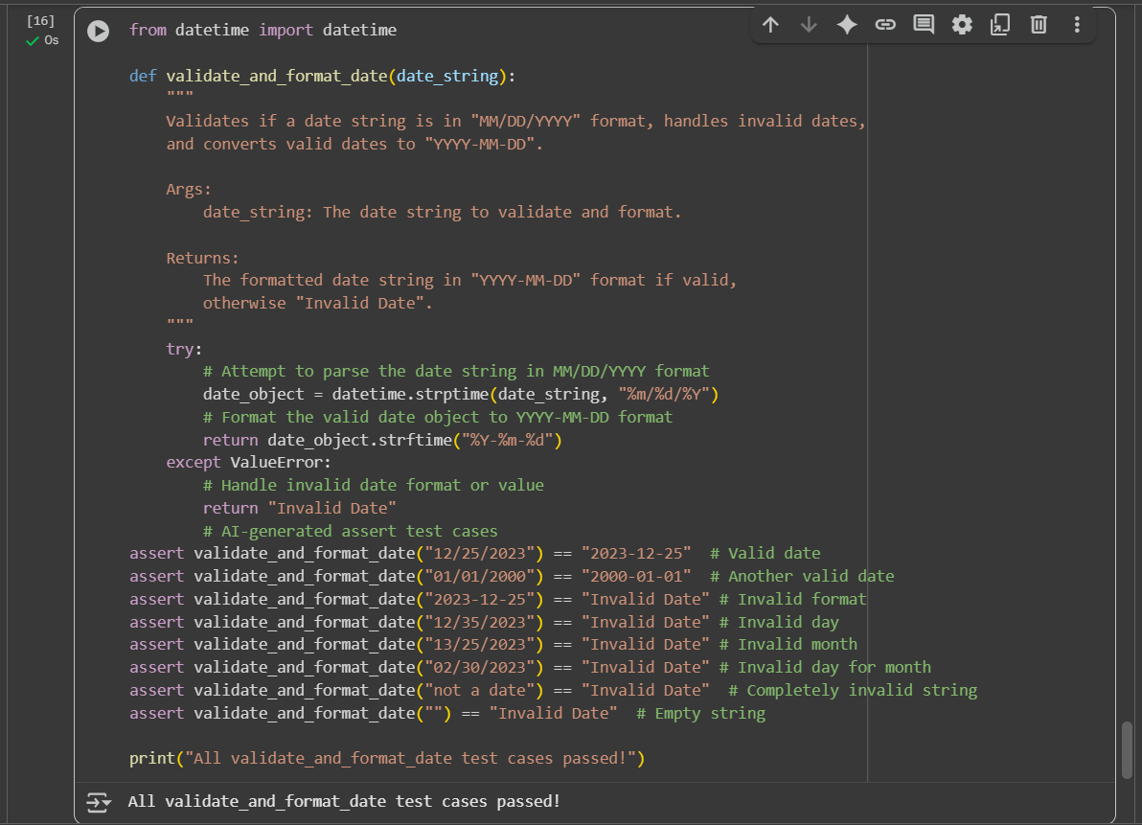

Code explanation:

I can explain the Python code you provided. This code defines a function validate_and_format_date that checks if a date string is in a specific format, handles invalid dates, and converts valid dates to a different format. It also includes several assert test cases to verify the function's behavior.

Here's a breakdown:

1. **from datetime import datetime**: This line imports the datetime class from the datetime module. The datetime class is used to work with dates and times.
2. **def validate_and_format_date(date_string):**: This line defines a function named validate_and_format_date that takes one argument, date_string, which is the string containing the date to be validated and formatted.
3. **The Docstring ("""Docstring goes here""")**: This block of text explains what the function does, its arguments (Args), and what it returns (Returns). It clarifies that it validates and formats a date string, handling invalid dates.
4. **try:**: This keyword starts a try block. Code within a try block is executed, and if an error (exception) occurs, the code within the corresponding except block is executed. This is used here to gracefully handle potential errors that might occur during date parsing.
5. **date_object = datetime.strptime(date_string, "%m/%d/%Y")**: This is the core of the validation and parsing.
   * datetime.strptime(): This is a class method of datetime that parses a string representing a date and time according to a specified format.
   * date_string: This is the input string that the function is trying to parse.
   * "%m/%d/%Y": This is the format code string. It tells strptime to expect the date string in the format "month/day/year", where:
     + %m represents the month as a zero-padded decimal number (e.g., 01, 12).
     + %d represents the day of the month as a zero-padded decimal number (e.g., 01, 31).
     + %Y represents the year with century as a decimal number (e.g., 2023).
   * If the date_string successfully matches this format and represents a valid date, strptime returns a datetime object, which is stored in the date_object variable. If the string does not match the format or represents an invalid date (like 13/25/2023 or 02/30/2023), a ValueError is raised.
6. **return date_object.strftime("%Y-%m-%d")**: If the strptime call in the try block is successful (meaning the date string was valid), this line is executed.
   * date_object.strftime("%Y-%m-%d"): This is a method of the datetime object that creates a string representation of the date and time, formatted according to the specified format code string.
   * "%Y-%m-%d": This format code string tells strftime to format the date as "year-month-day" (e.g., 2023-12-25).
   * The function then returns this newly formatted date string.
7. **except ValueError:**: This keyword starts an except block that specifically catches ValueError exceptions. If a ValueError occurs in the try block (which happens when strptime fails to parse the date string), the code within this block is executed.
8. **return "Invalid Date"**: If a ValueError is caught, it means the input date_string was not in the expected "MM/DD/YYYY" format or represented an invalid date. In this case, the function returns the string "Invalid Date".
9. **# AI-generated assert test cases**: This is a comment indicating the start of the assert test cases.
10. **assert validate_and_format_date("12/25/2023") == "2023-12-25" # Valid date**: This assert statement checks if calling validate_and_format_date with a valid date string "12/25/2023" returns the correctly formatted string "2023-12-25".
11. **assert validate_and_format_date("01/01/2000") == "2000-01-01" # Another valid date**: This tests another valid date string.
12. **assert validate_and_format_date("2023-12-25") == "Invalid Date" # Invalid format**: This tests a date string that is in a different format (YYYY-MM-DD) and asserts that it is correctly identified as "Invalid Date".
13. **assert validate_and_format_date("12/35/2023") == "Invalid Date" # Invalid day**: This tests a date string with an invalid day (35) for the month, asserting it's an "Invalid Date".
14. **assert validate_and_format_date("13/25/2023") == "Invalid Date" # Invalid month**: This tests a date string with an invalid month (13).
15. **assert validate_and_format_date("02/30/2023") == "Invalid Date" # Invalid day for month**: This tests a date string with a day that is invalid for the specific month (February 30th).
16. **assert validate_and_format_date("not a date") == "Invalid Date" # Completely invalid string**: This tests a string that is clearly not a date format.
17. **assert validate_and_format_date("") == "Invalid Date" # Empty string**: This tests an empty string as input.
18. **print("All validate_and_format_date test cases passed!")**: If all the assert statements pass without raising an AssertionError, this line is executed, indicating that the tests were successful.

In summary, the code uses a try-except block with datetime.strptime to attempt to parse the input string in the "MM/DD/YYYY" format. If successful, it formats the resulting date object to "YYYY-MM-DD". If a ValueError occurs during parsing (due to incorrect format or invalid date values), it catches the exception and returns "Invalid Date". The assert statements provide examples and checks for various valid and invalid date inputs.